**THE TABLEAU HR SCORECARD : MESASURING SUCCESS IN TALENT MANAGEMENT**

1.Introduction

1.1.Overview:

1.2.Purpose:

2. Problem Statement & Design Thinking

2.1. Empathy Map:

2.2. Ideation & Brainstorming Map:

3. Result

4. Advantages & Disadvantages

5. Applications

6. Conclusion

7. Future Scope

**1.Introduction:**

**In the dynamic and competitive landscape of today's business world, human capital is recognized as one of the most valuable assets of any organization. Effectively managing and leveraging this resource has become a key strategic imperative. Talent management encompasses the entire employee lifecycle – from attracting top talent to nurturing their growth, retaining them, and aligning their skills with the organization's strategic goals**

**1.1.Overview:**

In today's competitive business environment, talent management is a critical component of organizational success. To ensure that human resources are effectively utilized, HR departments must have tools and systems in place to measure, track, and improve their talent management processes. One such tool is the Tableau HR Scorecard, which leverages data visualization and analytics to help HR professionals gain valuable insights into their talent management efforts.

**1.2.Purpose:**

The purpose of the Tableau HR Scorecard is to provide HR professionals with a comprehensive and visual means of evaluating and improving talent management strategies within an organization. By presenting data in a clear and easily digestible format, it enables HR teams to make data-driven decisions, leading to better talent acquisition, development, and retention.

**2.Problem Statement:**

**Traditional HR practices often lack the ability to translate raw data into actionable insights. This poses a significant challenge for HR professionals when trying to make strategic decisions regarding talent management. The Tableau HR Scorecard aims to address this issue by offering a solution that allows HR teams to leverage their data effectively.**

**2.Design Thinking:**

**(i).Data Gathering: Collect relevant HR data, including recruitment metrics, employee performance data, turnover rates, and employee engagement scores.**

**(ii).Data Preparation: Clean and structure the data, ensuring it's ready for analysis.**

**(iii).Data Visualization: Use Tableau's powerful data visualization tools to create meaningful, interactive dashboards that display key HR metrics.**

**(iv).Analysis: Interpret the data to identify trends, challenges, and opportunities within the organization's talent management processes.**

**(v).Actionable Insights: Use the insights to make informed decisions, such as improving recruitment strategies, optimizing training and development programs, and enhancing employee engagement.**

**2.1.EMPATHY MAP:**

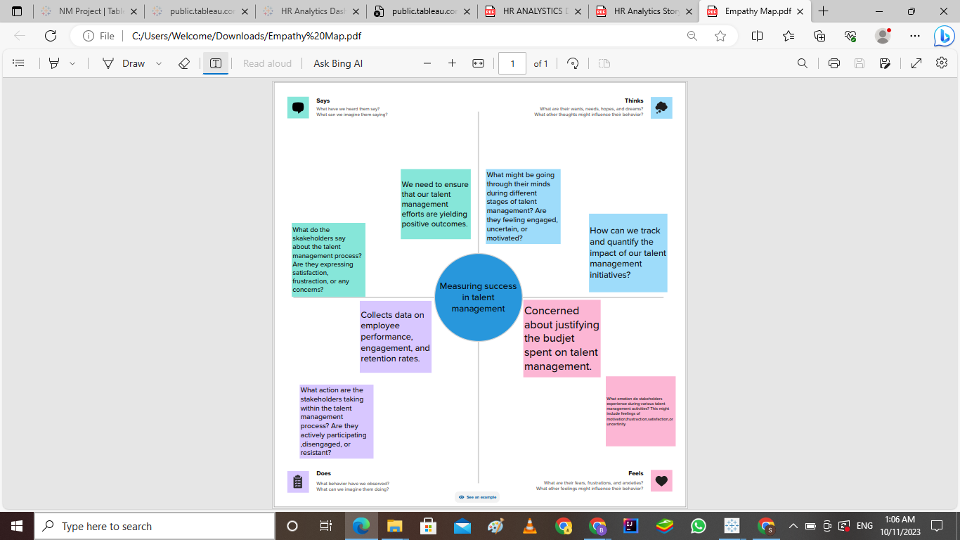

**2.2. Ideation & Brainstorming Map:**

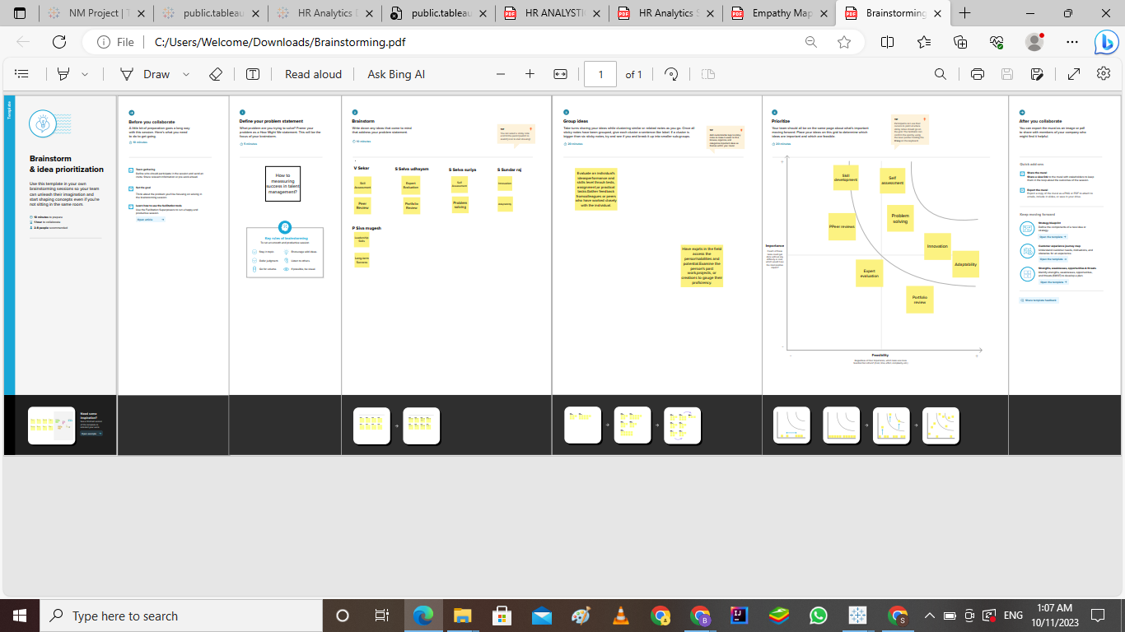

**3.Results:**

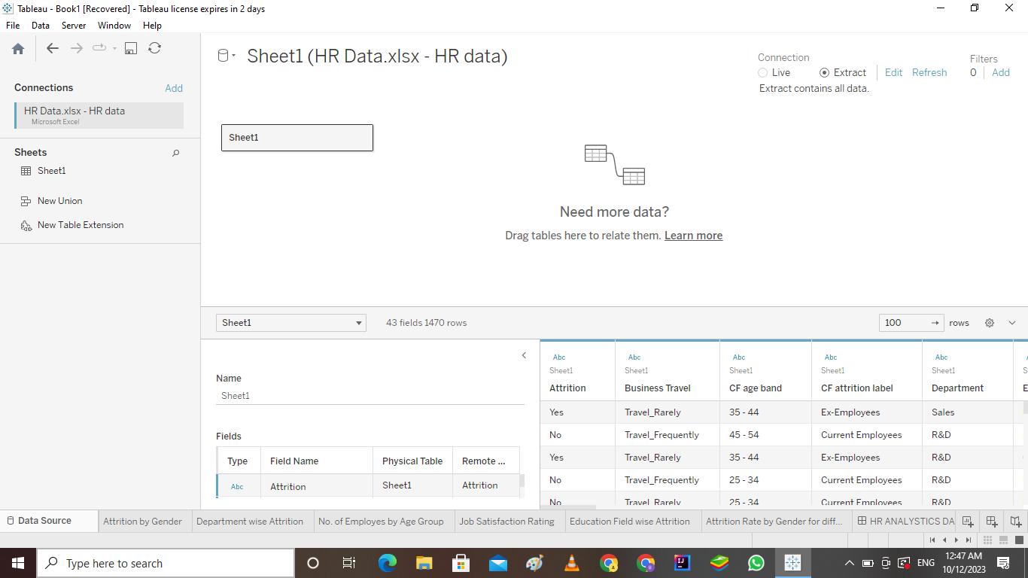

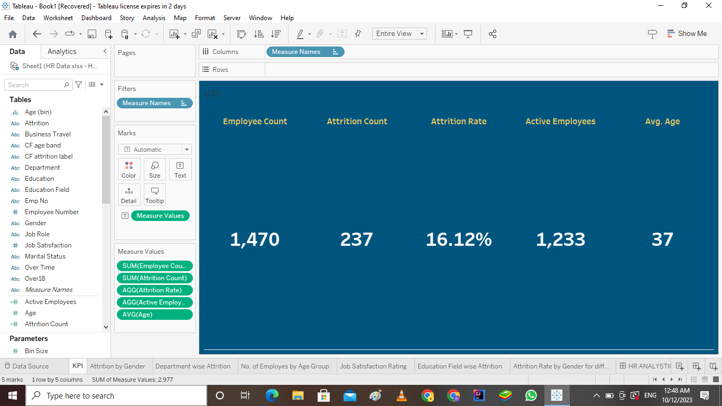

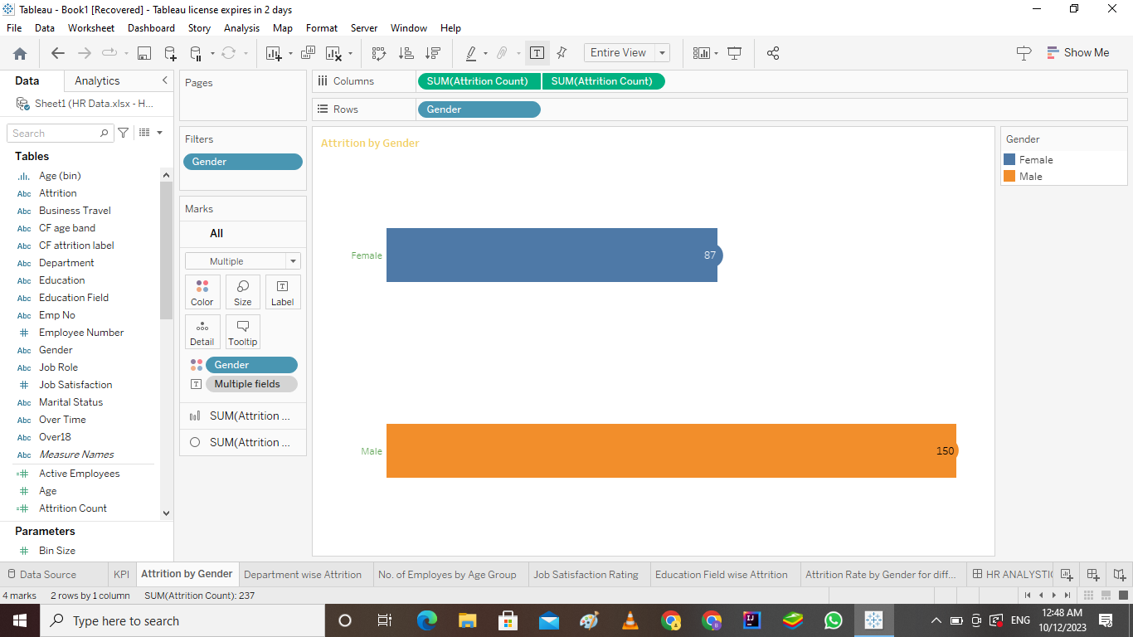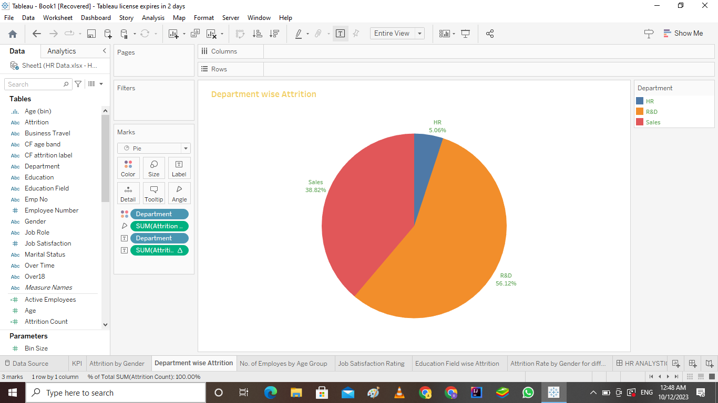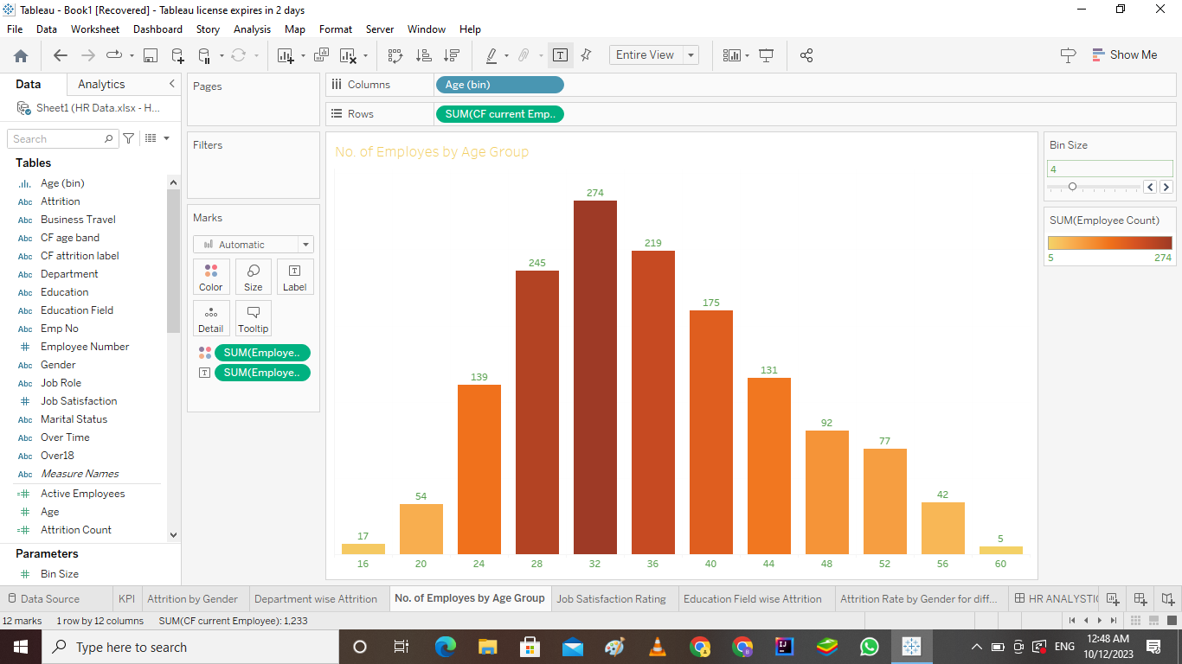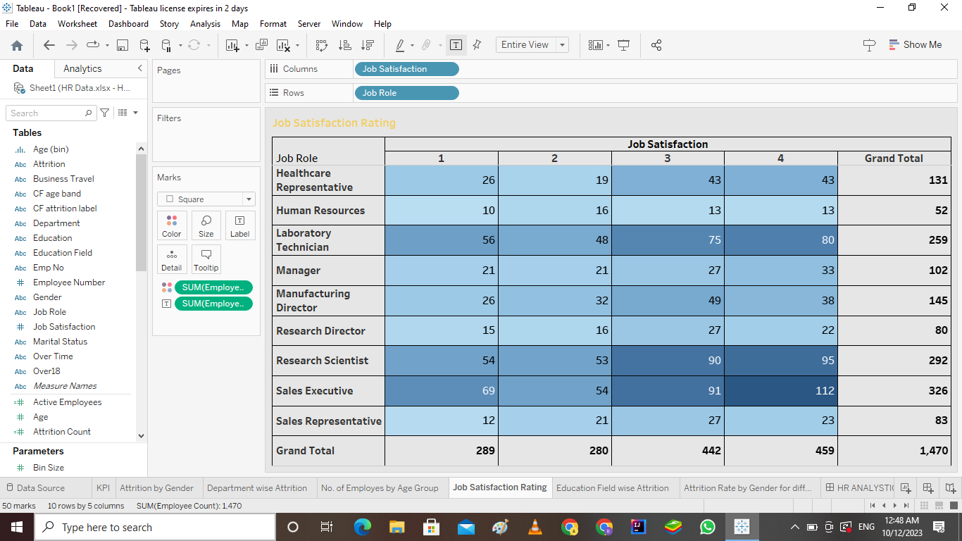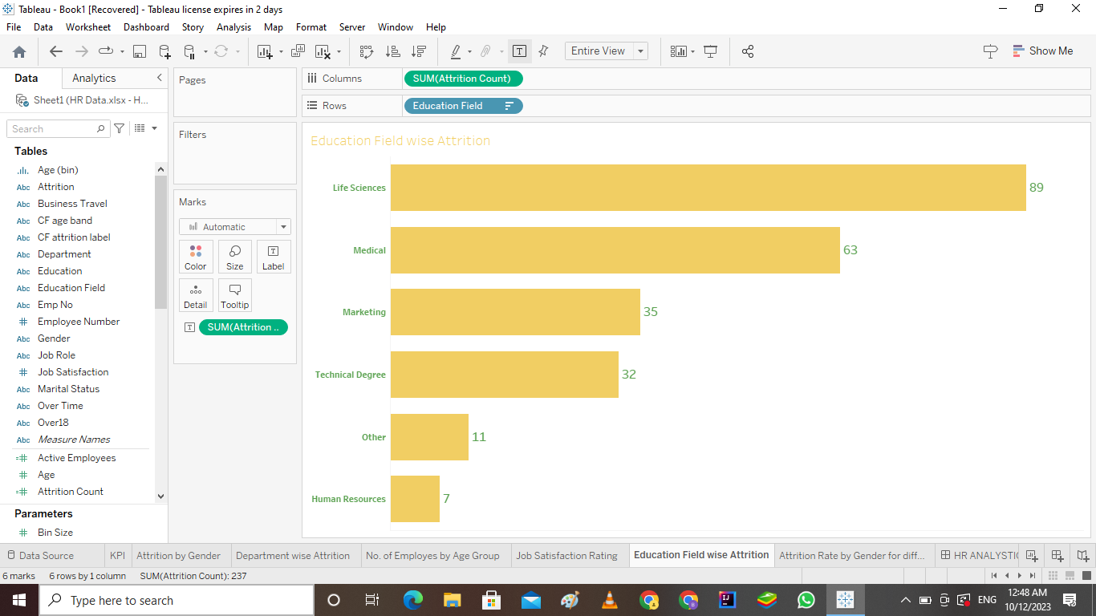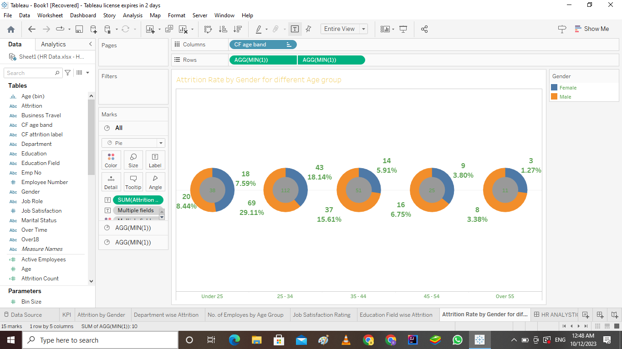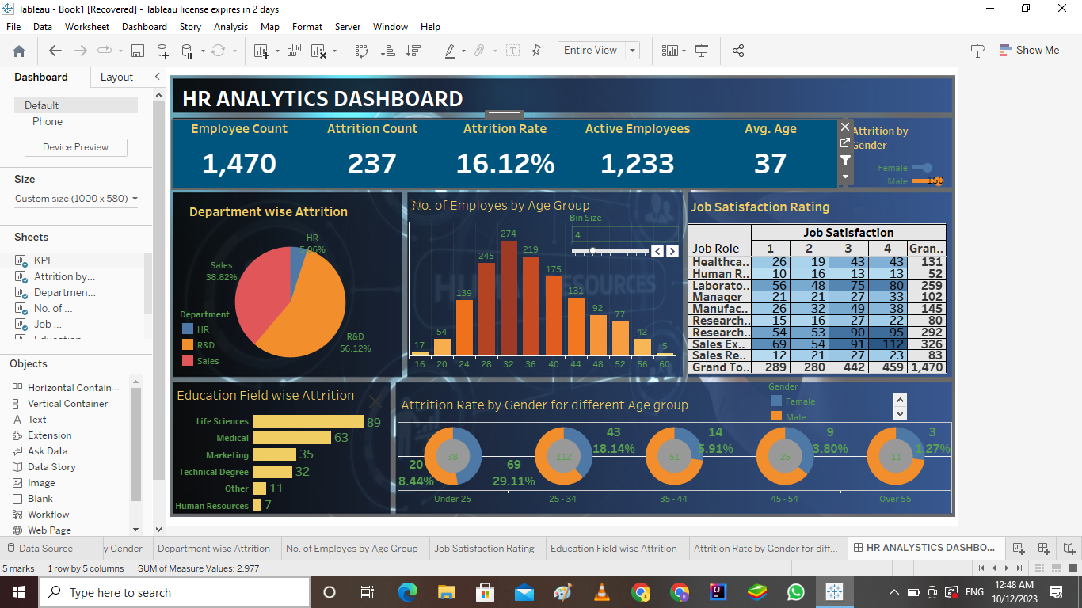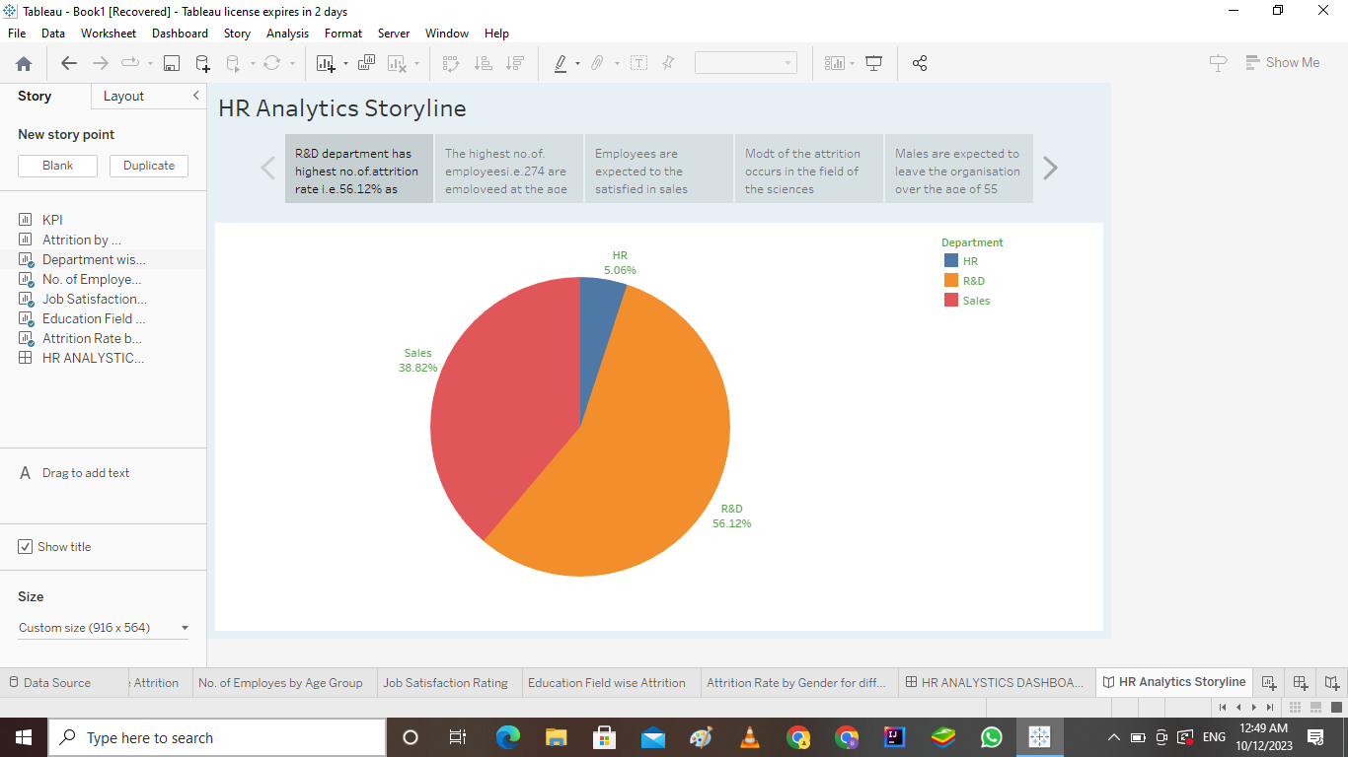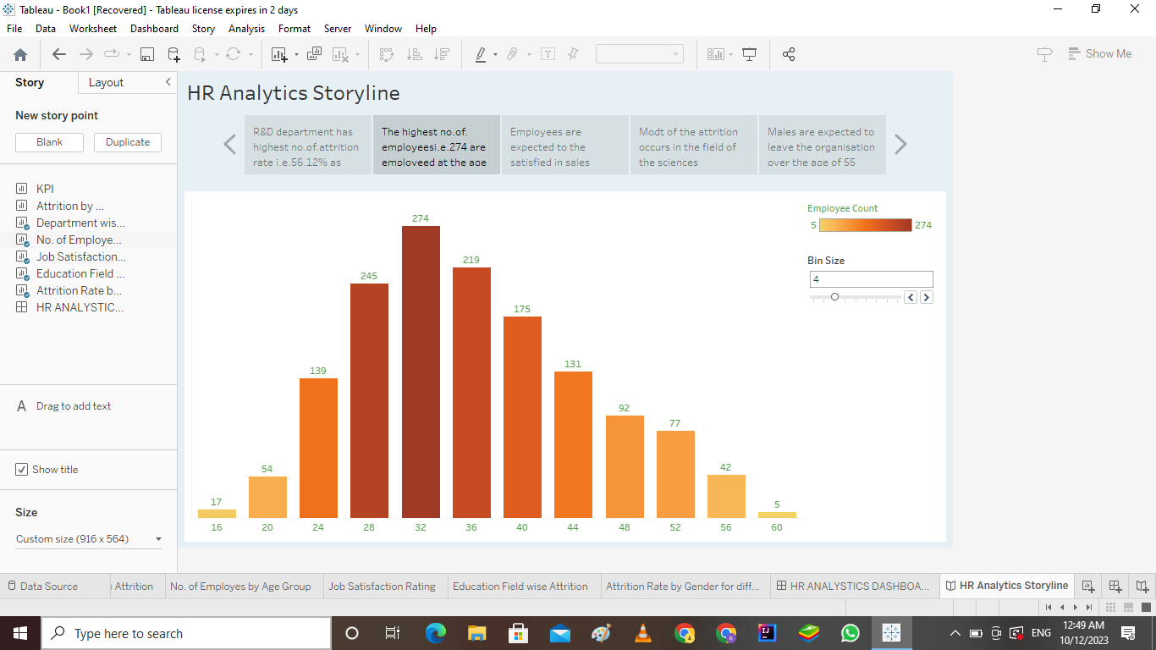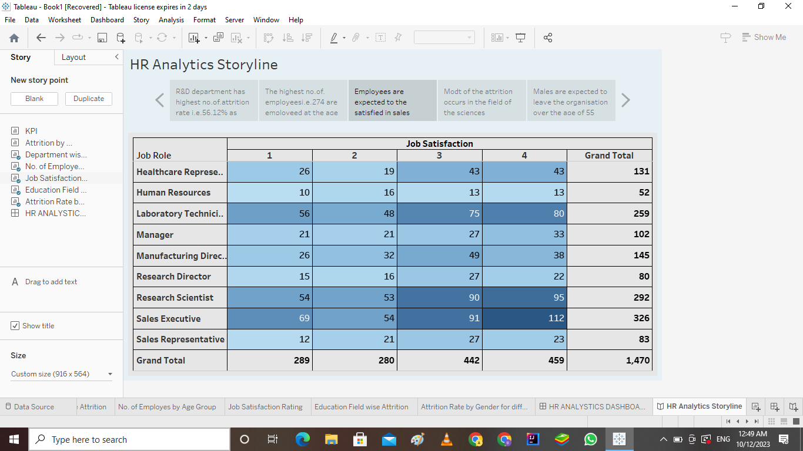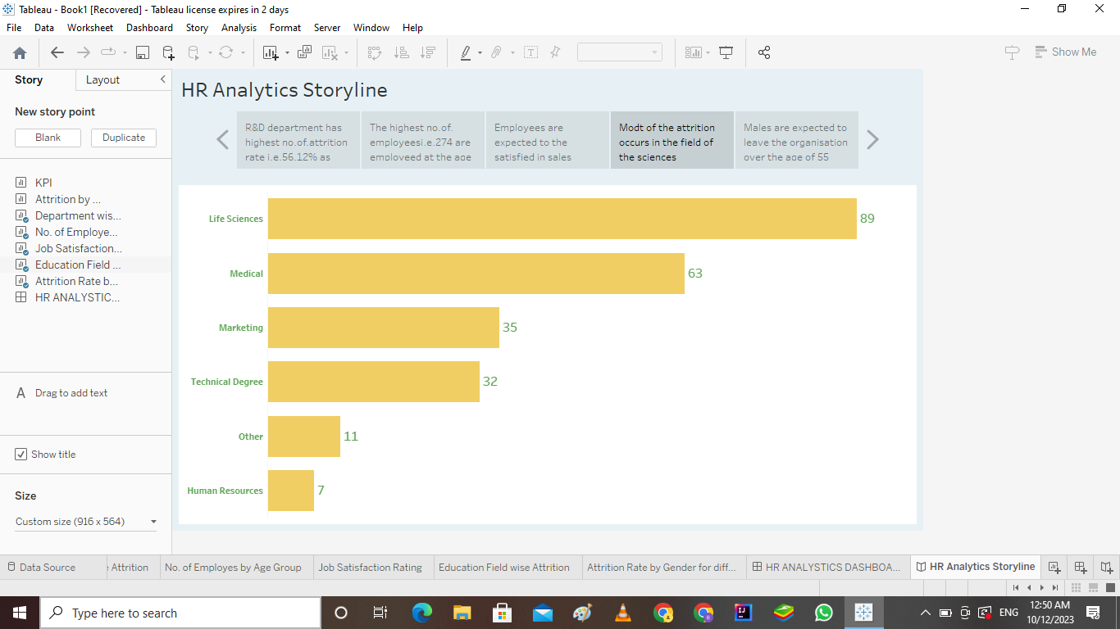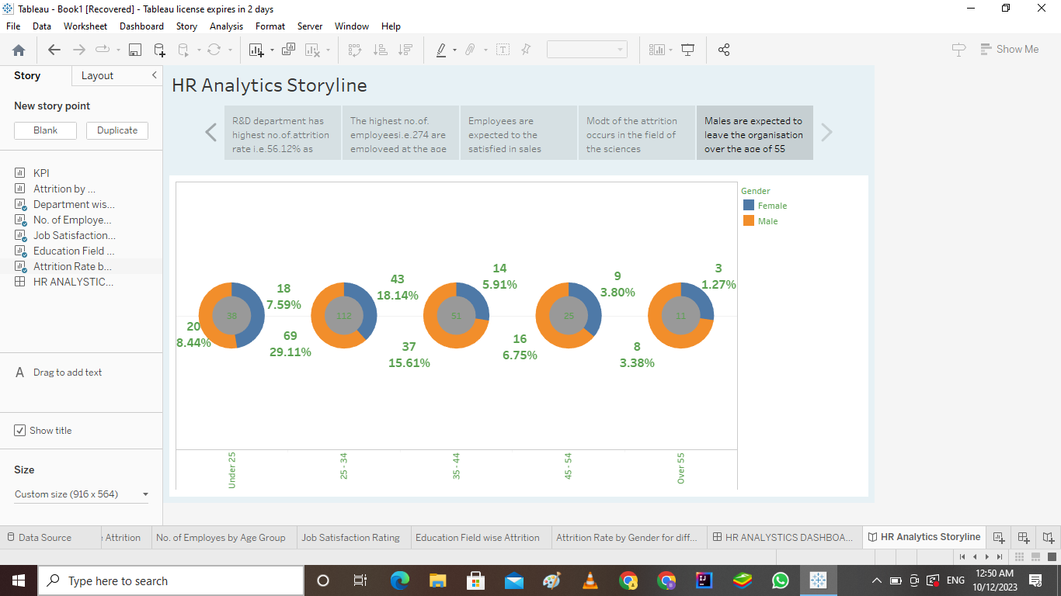

**4.Advantages:**

**(i).Visual Insights: Data visualization allows for a quick and clear understanding of HR performance metrics.**

**(ii).Data-Driven Decision-Making: HR professionals can make decisions based on concrete data rather than relying on intuition.**

**(iii).Real-time Monitoring: The scorecard can be updated in real-time, allowing for ongoing assessment and quick responses to changes.**

**(iv).Improved Talent Management:**

**Enhance talent acquisition, development, and retention strategies by identifying areas for improvement.Enhanced Communication: Visual dashboards make it easier to communicate HR performance to stakeholders and senior management.**

**Disadvantages:**

**(i).Data Quality: The accuracy and reliability of the scorecard heavily depend on the quality of the underlying data.**

**(ii).Resource Intensive: Developing and maintaining the scorecard can be resource-intensive, especially in terms of data collection and preparation.**

**5.Application:**

**The Tableau HR Scorecard can be applied across various HR functions, including:**

**(i).Recruitment: Tracking the effectiveness of different sourcing channels and evaluating the quality of hires.**

**(ii).Training and Development: Assessing the impact of training programs on employee performance and engagement.**

**(iii).Performance Management: Monitoring employee performance and identifying areas for improvement.**

**(iv).Retention: Identifying turnover trends and their underlying causes.**

**6.Conclusion:**

**The Tableau HR Scorecard is a valuable tool for HR professionals, offering a data-driven approach to talent management. By transforming data into actionable insights, it empowers HR teams to make strategic decisions that can enhance an organization's overall performance and competitiveness.**

**7.Future Scope:**

**As data analytics and visualization tools continue to evolve, the Tableau HR Scorecard can be expected to become even more powerful and accessible. Future developments may include predictive analytics to forecast HR-related trends and the integration of AI and machine learning for more advanced insights. Additionally, it can be customized to suit the unique needs of different organizations, ensuring its continued relevance in the ever-evolving field of HR.**